Barry Rosenfeld, Ph.D.

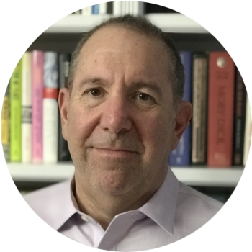



l



*Dr. Barry Rosenfeld is a Professor of Psychology (currently Department Chair) and Adjunct Professor of Law at Fordham University. Dr. Rosenfeld received his doctorate in Clinical Psychology from the University of Virginia and completed a post-doctoral fellowship in bio-ethics and consultation-liaison psychology at Memorial Sloan-Kettering Cancer Center. He also serves as a member of the editorial board of several prominent psychology journals including Law and Human Behavior, Assessment, and Psychological Assessment. Dr. Rosenfeld has published more than 200 peer-reviewed articles, book chapters, books and invited publications. His research encompasses a wide range of topics related to forensic and health psychology, including malingering, stalking and violence risk assessment, as well as treatment decision-making, desire for hastened death and refugee mental health. Rosenfeld is board certified in forensic psychology and maintains an active forensic/clinical practice, consulting on a wide range of legal matters. His practice involves evaluating individuals charged with a criminal offense or involved in civil litigation, but he has been frequently retained to consult on international matters*

**Spring Colloquium Sponsored by the**

**Clinical Psychology Doctoral Program**

*“What We Talk About When We Talk About Diversity”*

**Date:** Friday, April 22, 2022

**Venue:** RM 321

*Lowman Student Center*

**Time:** 10:00 a.m. – 11:30 a.m.

For more information, please contact the Clinical Psychology Doctoral Program at 936-294-1210

Sam Houston State University

Clinical Psychology Doctoral Program

Tel. 936.294.1210